Integrating the Healthcare Enterprise



IHE Patient Care Coordination (PCC)

Technical Framework Supplement

Newborn Discharge Summary
(NDS)

Public Comment

Date: February 2, 2010
Author: Alan E Zuckerman MD
Email: aez@georgetown.edu
Foreword
This page is standard language for all IHE supplements. The Introduction section following will list all other IHE documents that are modified by this supplement. This document is a supplement to the IHE Patient Care Coordination Technical Framework 4.0. The technical framework can be found at http://www.ihe.net/Technical_Framework/index.cfm#pcc.
This and all IHE supplements are written as changes to a base document. The base document is normally one or more IHE Final Text documents. Supplements tell a technical editor and the reader how to modify the final text (additions, deletions, changes in wording). In order to understand this supplement, the reader needs to read and understand all of the base documents that are modified by this supplement.
In this supplement you will see “boxed” instructions similar to the following:
Replace Section X.X by the following:
These “boxed” instructions are for the author to indicate to the Volume Editor how to integrate the relevant section(s) into the overall Technical Framework.
This format means the reader has to integrate the base documents and the supplement. When the material in the supplement is considered ready for incorporation into the final text of the Technical Framework, the IHE committees will update the technical framework documents with the final text. Supplements are written in this format to avoid duplication material. This means that two IHE documents (one possibly final text, and the other a supplement) should not contain contradictory material.
Text in this document is not considered final for the Technical Framework. It becomes Final Text only after the IHE PCC Technical Committee ballots the supplement (after testing) and agrees that the material is ready for integration with the existing Technical Framework documents.
It is submitted for Trial Implementation starting August XX, 20XX.
Comments on this supplement may be submitted http://forums.rsna.org:
- Select the “IHE” forum
- Select Patient Care Coordination Technical Framework
- Select 2009-2010 Supplements for Public Comment
- Select Immunization Care Plan

Please use the Public Comment Template provided there when starting your New Thread.
Details about IHE may be found at: www.ihe.net
Details about the IHE Patient Care Coordination may be found at: http://www.ihe.net/Domains/index.cfm
Details about the structure of IHE Technical Frameworks and Supplements may be found at: http://www.ihe.net/About/process.cfm and http://www.ihe.net/profiles/index.cfm

Introduction
This profile will add the Newborn Discharge Summary to Volume 1 and Volume 2 of the PCC Technical Framework. This will be a new content profile for 2010 that will include subsets of data already in other profiles such as APR and LDR.

Open Issues and Questions
- The Vital Records Birth Registration does not yet exist as a Content Profile but is one of the context areas that will interact with the NDS. Use of a placeholder may be appropriate
- The content creator of an NDS also functions as a content consumer for other profiles such as the APR or LDR. Proper representations of these roles will be important
- Newborn screening lab results are sent to the hospital using HL7 v2.5.1 messages and public health labs will not generate V3 XD-Lab reports but having such document reports will be useful. There is no profile for newborn screening labs but one is not necessary because it builds on existing lab message profiles constrained by special vocabularies and sample messages developed and maintained at NLM. It is not clear whether a profile is needed for newborn screening labs (NBSL) or if the NDS can be a content consumer for NBSL and integrate the data into the NDS eliminating the need for a separate XD-Lab document or a newborn screening lab document conforming to XD-lab could be produced and included in a folder with the NDS. It also would be possible to create a separate content profile for newborn screening, but it may be more appropriate to keep newborn screening results as part of the laboratory result section of a newborn discharge medical summary.
- Newborn Hearing Screening is being developed as its own profile in 2010 and until it is complete and it is clear what it include, it must be a placeholder for NDS
- The NDS includes data on both the mother and the infant that are stored in the infant’s record. It will be necessary to carefully develop methods for correctly identifying the patient on which the data elements were collected.
- A special problem occurs in the problem list where problems identified in the mother are relevant for the infant and should either be entered as part of the family history using the codes and terms relevant to the mother, or in the infant’s problem list under a different code and term such as exposure to HIV for the infant whose mother has HIV. Qualifiers such as “Family History of …” do not work correctly for the infant’s problem list and can misidentify infants as having problems which they do not have but may only be at risk for.

Closed Issues
< List of closed issues/ questions with their resolutions that have been addressed prior to publishing of the Technical Framework>
TABLE OF CONTENTS

Volume 1 – Profiles 6
1.1.5 Copyright Permissions 6
2.5 Dependencies of the PCC Integration Profiles 6
2.7 History of Annual Changes 6
X <Newborn Discharge Summary Content/Integration> Profile 6
X.1 Purpose and Scope 7
X.2 Use Cases 9
X.3 Actors/Transactions 10
X.4 Options 12
X.5 Groupings 13
X.6 Security Considerations 13
X.7 Requirements of Actors 13
X.8 Content Modules 14
X.9 Process Flow 15
<Appendix A> Actor Summary Definitions 16
<Appendix B> Transaction Summary Definitions 16
Glossary 17
Volume 2 – Transactions and Content Modules 17
3.0 IHE Transactions 17
3.Y <Transaction Name> 17
3.Y.1 Scope 17
3.Y.2 Use Case Roles 17
3.Y.3 Referenced Standard 18
3.Y.4 Interaction Diagram 18
3.Y.4.1 <Message_1 Name> 18
3.Y.4.1.1 Trigger Events 18
3.Y.4.1.2 Message Semantics 18
3.Y.4.1.3 Expected Actions 18
3.Y.4.2 <Message_2 Name> 19
3.Y.4.2.1 Trigger Events 19
3.Y.4.2.2 Message Semantics 19
3.Y.4.2.3 Expected Actions 19
3.Y.5 Security Considerations 19
3.Y.5.1 Security Audit Considerations 19
3.Y.5.1.(z) Actor Specific Security Considerations 19
5.0 Namespaces and Vocabularies 19
5.1 IHE Format Codes 20
6.0 PCC Content Modules 20
6.2 Folder Content Modules 20
6.2.Y <Folder Specification Name> 20
6.3 HL7 Version 3.0 Content Modules 20
6.3.1 CDA Document Content Modules 20
6.3.1.A <Document Content Module Specification Name> 20
6.3.2 CDA Header Content Modules 21
6.3.2.B <Header Content Module Specification Name> 21
6.3.3 CDA Section Content Modules 21
6.3.3.C <Section Content Module Specification Name> 21
6.3.4 CDA Entry Content Modules 21
6.3.4.D <Entry Content Module Specification Name> 21
6.5 PCC Value Sets 21
6.5.A <Value Set Name> 21
<Appendix letter> Appendix_Name 21

Volume 1 – Profiles
Add the following to section 1.1.5
1.1.5 Copyright Permissions

Add the following to section 2.5
2.5 Dependencies of the PCC Integration Profiles
Medical Summary (MS)
Antepartum Record (APR)
Antepartum History and Physical (APHP)
Antepartum Summary (APS)
Antepartum Lab (APL)
Labor and Delivery Record (LDR)
Newborn Screening (NBS)
Newborn Hearing Screening - placeholder
Vital Record Birth Certificate – placeholder for future profile

Add the following to section 2.7
2.7 History of Annual Changes

The Newborn Discharge Summary is a new profile this year but it includes material from the APS and LDR that are being updated from prior years.

Add Section X
X Newborn Discharge Summary Content Profile

The Newborn Discharge Summary is produced when a newborn infant is discharged from the birthing facility. For 2010 the scope will be constrained to newborn discharges cared for in a normal newborn nursery and will not include infants with complex problems care for in a NICU. The NDS draws heavily on other content profiles such as APR and LDR and can also be used to display the results of newborn screening tests when they are available. As newborn screening results may not be available until after the newborn goes home, updating the NDS can be an effective strategy for transferring these results to future medical home because the medical home is not always identified before the infant leaves the hospital but the family can always identify the birthing facility where the birth occurred.

Newborn hospital discharge represents the first transfer of care for the over 4 million infants born in the United States each year and the NDS can play a critical role in creating a new ambulatory EHR for the infant at the time of their first office visit which is usually 2 or 3 days after they leave the birthing. Information recorded on the NDS can accurately be filed in the infant’s lifetime record. The NDS also can play a critical role in assuring that all care requirements identified during newborn hospitalization are met after discharge and can provide the basis for quality measurement reporting and provide data required for clinical decision support.

X.1 Purpose and Scope

The newborn discharge is produced when a newborn infant leaves the hospital and can play a critical role in creating a new ambulatory EHR at the time of the first visit following discharge. Many of the data elements that are recorded on the NDS should become a part of the lifetime record but often are not available in an infant’s record if data is not transferred from the hospital. Ideally this data, such as the birth weight, time of birth, discharge weight, and hepatitis B immunization, should be discretely imported into the ambulatory record, but it is useful to import that data as an intact document. The same NDS can also be used to start a personal health record for the infant.

For 2010, the NDS will be constrained in scope to the care of a newborn who did not require special care in a Neonatal Intensive Care Unit (NICU) and did not have any complex problems requiring extended stay or more complex treatment. In future years, the scope of the NDS can be expanded to include the more complex events that occur during NICU admissions

The NDS is an example of a short stay hospital record (as sanctioned by JCAHO) where a single document serves several functions. A short stay hospital record includes the admission history and physical, a discharge note and all significant progress notes so that it contains all necessary elements of a hospital discharge summary and a separate dictated discharge summary is not required. A short stay hospital record produces the discharge summary as an on-going process during the hospital stay rather than as a separate process.

Much of the data required to complete a NDS is available in other documents found other places such as the Antepartum Record and in the Labor and Delivery Record. An important purpose of the NDS to provide accurate capture and re-use of data that was originally collected on the mother but that is of significance to the infant

A key purpose of the NDS is to coordinate care that is incomplete at the time of discharge and that will need to be completed in the ambulatory setting such as repeat hearing screening or consults or imaging studies that were ordered but not completed during the hospital or birthing facility stay.

Clinical decision support can be used to determine care requirements for newborns after discharge and a key purpose of the NDS is to provide necessary data elements to drive CDS in the ambulatory setting

Quality of care measures are being developed by NCQA to track completion of all mandated newborn screening activities. The NDS is expected to provide key data elements necessary to measure quality which will involve integration of data from the hospital or birthing center with data from ambulatory care.

Family history is an important component of an infant’s medical record and newborn discharge is a good time to collect an initial family history. The NDS will include sections in the medical summary designed to contain the family history. Tools are available to collect family history that could be utilized to transfer data to the NDS.

During the newborn hospital or birthing facility stay, the infant is identified as BabyBoy or BabyGirl and special pediatric demographics are used to handle multiple births. Before the infant leaves the hospital a birth certificate registration is usually completed and filed with vital records. The birth certificate also contains data about the parents , such as mother’s education level, in addition to the infant’s name. It will be useful to extract data such as birth weight from the NDS for use in completing the birth certificate registration and data from the national standard electronic birth certificate (plus individual state additions) will be useful for updating the NDS with complete and accurate demographics

Because normal newborn hospitalizations are extremely brief, the results of many screening tests are not available when the infant leaves the hospital or birthing facility. These results will be returned to the hospital where the tests were ordered but most newborns are not cared for by the same provider during the newborn hospital admission and afterwards in the medical home. It will be extremely useful to update the NDS with the results of newborn screening tests and to make this updates available to future providers since the future primary care provide and medical home are often not known at the time of discharge but the hospital of birth is almost always know to future providers who can query for this data at the hospital of birth. A provider seeing the newborn for the first time in an ambulatory setting could register with the hospital to receive notice of document availability when results of newborn screening are sent to the hospital.

The hospital is usually responsible for completing newborn hearing screening if this was not done during the admission and this is often done at a hospital run ambulatory hearing testing facility. The results of the hearing test (or re-test) can also be added to the NDS post discharge (completing an order placed during the admission) and this new information made available through a notice of document availability.

The range of problems, data observations, procedures, and medication that are relevant to care provided in the normal newborn nursery is quite limited and this content profile will include tables of commonly used codes including mapping of ICD9, ICD10, and SNOMED codes for describing common newborn conditions and targets of newborn screening. This coding vocabulary subsets should be used to improve the quality of ambulatory problem lists in future records built from the NDS.

X.2 Use Cases

X.2.1 A normal newborn with no special problems
A normal newborn discharge illustrates all of the features of the profile

- The initial observations on the newborn are recorded in the infant section of the labor and delivery record including the birth weight, apgar scores, and other measurements.
- When the infant is admitted to the normal newborn nursery a newborn discharge summary is created as the electronic medical record for the newborn
- Selected data from the Mother’s antepartum history and physical is transferred to the NDS or entered manually

X.2.2 An infant who fails to pass newborn hearing screening
A normal newborn who fails to pass the most recent hearing screening before discharge from the hospital will require additional testing after hospital discharge. The NDS contains only the results of the most recent hearing test performed prior to discharge.

X.2.3 An infant with hyperbilirubinemia
Some infants will develop jaundice due to elevation serum bilirubin that will require diagnostic studies and possible therapy during the newborn hospitalization and potentially after discharge. Severe elevations of bilirubin are rare, but can cause brain damage and a key role of the newborn discharge summary is to provide data for clinical decision support to determine the need for therapy and to coordinate care provided in the hospital with care required after discharge. Some infants will have transcutaneous bilirubin measurements performed at the bedside. Some infants will have blood drawn (usually by heel stick) for laboratory measurement of bilirubin and those results will usually be returned as HL7 v2.x lab results messages. All infants will have the mother’s blood type measured as part of the antepartum labs. Some infants will have the infant’s

X.2.4 An infant born to an HIV positive mother
When a mother is known to infected with HIV, treatment is started during pregnancy and delivery to prevent transfer of the virus to the newborn. This treatment must be continued

X.2.5. An infant born to a mother who is positive for Hepatitis B antigen
An infant born to a mother who is known to be Hepatitis B antigen positive requires special treatment because they must receive both the Hepatitis B vaccine (which might be optional or deferred in other infants) and the Hepatitis B Hyperimmune Globulin (which provides passive immunity). It will be important to use the NDS to communicate the Hepatitis B lab results from the mother, the immunizations given to infant, and the plan of care that documents the need for future testing and careful observation of the infant to assure that maternal infant transmission of hepatitis has not occurred.

X.2.6 An infant with a heart murmur
A heart murmur is a common finding in newborns and most are not associated with congenital heart disease. Some significant congenital heart disease is not detected by examining the infant and it has been proposed that all newborns be screening by measuring pulse oxygenation (a vital sign on the medical summary) and this practice is undergoing evidence based review.

X.2.7 An infant with a congenital malformation such as equinovarus (club foot)
Many congenital malformations are not life threatening and do not require immediate therapy. A key role for the NDS is to document which diagnostic studies and consultations were completed during the hospitalization and which ones have been scheduled

X.3 Actors/Transactions
<Actors are roles that are played by a system. A system may have multiple actors. This section shall contain Actor/Transaction diagrams and an Actor/Transaction table. See below for general guidelines for Actors/Transactions>
Figure X.3-1 shows the actors directly involved in the <Newborn Discharge Summary> Integration Profile and the relevant transactions between them. Other actors that may be indirectly involved due to their participation in <other related profiles>, etc. are not necessarily shown.

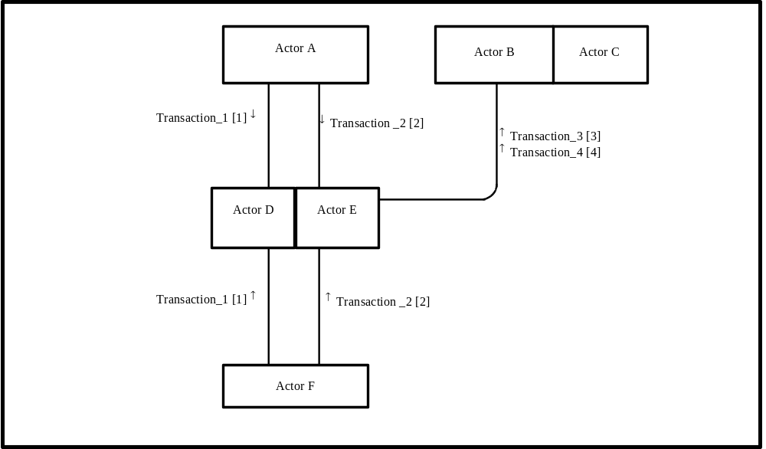
Figure X.3-1. Newborn Discharge Summary Actor Diagram
Table X.3-1 lists the transactions for each actor directly involved in the <Newborn Discharge Summary> Profile. In order to claim support of this Integration Profile, an implementation must perform the required transactions (labeled “R”). Transactions labeled “O” are optional. A complete list of options defined by this Profile and that implementations may choose to support is listed in Volume I, Section X.4.

Table X.3-1. Newborn Discharge Summary Integration Profile - Actors and Transactions
Actors | Transactions | Optionality | Section in Vol. 2
Actor A | Transaction_1 | R | Z.1
Actor A | Transaction_2 | R | Z.2
Actor F | Transaction_1 | R | Z.1
Actor F | Transaction_2 | R | Z.2
Actor D/ Actor E | Transaction_1 | R | Z.1
Actor D/ Actor E | Transaction_2 | R | Z.2
Actor D/ Actor E | Transaction_3 | R | Z.3
Actor D/ Actor E | Transaction_4 | R | Z.4
Actor B (Actor C) | Transaction_3 | R | Z.3
Actor B (Actor C) | Transaction_4 | R | Z.4
Note: This is a note

<Actors and Transactions are usually the same across PCC Content Profiles, below is an example of what should be used for these types of profiles. In future work these may be moved into a yet to be created PCC Technical Framework Volume 0.>

There are two actors in this profile, the Content Creator and the Content Consumer. Content is created by a Content Creator and is to be consumed by a Content Consumer. The sharing or transmission of content from one actor to the other is addressed by the appropriate use of IHE profiles described below, and is out of scope of this profile. A Document Source or a Portable Media Creator may embody the Content Creator Actor. A Document Consumer, a Document Recipient or a Portable Media Importer may embody the Content Consumer Actor. The sharing or transmission of content or updates from one actor to the other is addressed by the use of appropriate IHE profiles described in the section on Content Bindings with XDS, XDM and XDR. in PCC TF_2:4.1

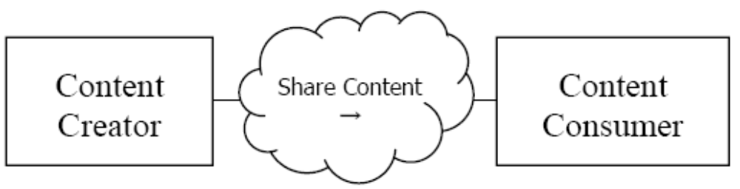
Figure X.3-1 Actor Diagram

X.4 Options
<This section contains a table describing the additional capabilities available for this profile and references to all sections that state requirements for compliance to the Option. Options in a Profile are synonomous with options on an automobile in that the purchaser of the automobile may choose the sunroof and upgraded stereo options, but is not required to do so in order to purchase and use the automobile. In another example the purchaser may have the option of an automatic transmission or a manual transmission. In this case the purchaser must choose one option or the other as a car cannot be driven without a transmission.>
Options that may be selected for this Profile are listed in the table X.4-1 along with the Actors to which they apply. Dependencies between options when applicable are specified in notes.
Table X.4-1 Newborn Discharge Summary - Actors and Options
Actor | Options | Vol & Section
Actor A | No options defined | - -
Actor F | No options defined | - -
Actor D/ Actor E | No options defined | - -
Actor D/ Actor E | No options defined | - -
Actor B (Actor C) | No options defined | - -
Actor B (Actor C) | No options defined | - -

<Options are usually the same across PCC Content Profiles, below is an example of what should be used for these types of profiles. In future work these may be moved into a yet to be created PCC Technical Framework Volume 0.>

Actor | Option | Section
Content Consumer | View Option (See Note 1)  Document Import Option (See Note 1)  Section Import Option (See Note 1)  Discrete Data Import Option (See Note 1) | PCC TF-2: 3.0.1  PCC TF-2: 3.0.2  PCC TF-2: 3.0.3  PCC TF-2: 3.0.4
Content Creator | No options defined
Note 1: The Actor shall support at least one of these options.

X.5 Groupings

<This section specifies Actors from other profiles, possibly in other domains, that this profile shall, may or should be grouped with; including any additional requirements placed upon them when grouped with actors of this profile (and vice versa).>

X.6 Security Considerations
<Description of the Profile specific security considerations. This should include the outcomes of a risk assessment. This likely will include profile groupings, and residual risks that need to be assigned to the product design, system administration, or policy.>

X.7 Requirements of Actors

X.7.1 Content Consumer APR / Content Creator NDS

X.7.2 Content Consumer LDR / Content Creator NDS

X.7.3 Content Creator NDS

X.7.4 Content Consumer NDS

X.7.5 Content Consumer Newborn Screening Labs / Content Creator NBS

X.8 Content Modules

This section is an early draft that will require considerable work to complete and will be described in supplemental spreadsheets keyed to the following table

Newborn Discharge Summary | CDA Section
Infant Pediatric Demographics | Pediatric Demographics
Mother’s Data
History of Previous Pregnancues | Pregnacy History
Antepartum Labs | Labs
Labor and Delivery Data | Results
Growth and other Measurements | Vital Signs
Newborn Admission Physical Exam | Physical Exam
Newborn Admission Problem List | Problems
Newborn Hospital Plan of Care | Plan of Care
Newborn Hospital Medications | Medication List
Newborn Discharge Physcial Exam | Physical Exam
Newborn Discharge Problem List | Problem List
Newborn Discharge Medications | Active Medications
Newborn Proceedures | Procedures
Newborn Consultations | Plan of Care
Newborn Discharge Plan of Care | Plan of Care
Results of Newborn Screening Labs | Labs
Results of Newborn Hearing Screening | Labs

X.9 Process Flow
<Description of the process flow(s) and sequence diagram(s) covered by this profile in order to satisfy the use cases. This often will include a brief description of the use cases as well. If there are detailed behavioral rules that apply to a specific process flow or multiple process flows or descriptions then an appendix may be added as needed>

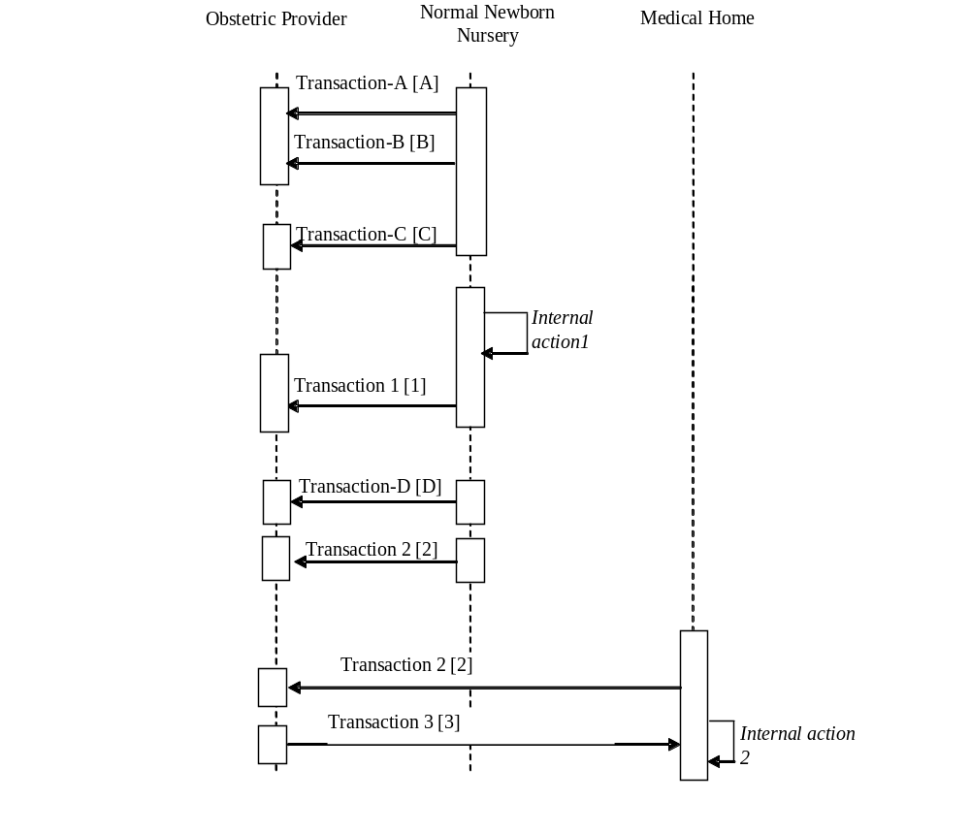
Figure X.9-1. Basic Process Flow in <Newborn Discharge Summary> Profile

<Appendix A> Actor Summary Definitions
<add any actor definitions for new actors defined specifically for this profile>

<Appendix B> Transaction Summary Definitions
<add any transaction definitions for new transactions defined specifically for this profile>

Glossary
Add the following terms to the Glossary:
<any glossary additions associated with the profile draft go here>

Volume 2 – Transactions and Content Modules
<A PCC Profile will have sometimes have Transactions, will sometimes have Content Modules, and sometime may have both. Following are guidelines on the content needed in sections for both Transactions and Content Modules.>

3.0 IHE Transactions

Add section 3.Y
3.Y <Transaction Name>
<This section corresponds to Transaction Y of the IHE Technical Framework. Transaction Y is used by the <ABC> and <DEF> actors. This section may or may not be present depending on the issues the profile addresses.>

3.Y.1 Scope

3.Y.2 Use Case Roles
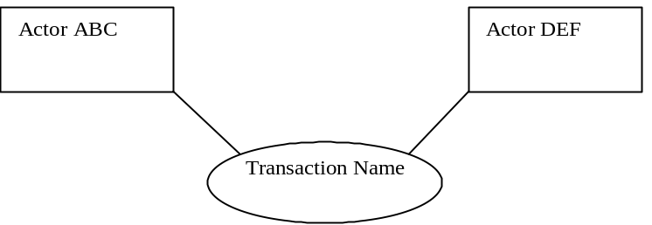

Actor:
Role:
Actor:
Role:
Actor:
Role: .

3.Y.3 Referenced Standard
<e.g., HL7 2.3.1 Chapters 2, 3>
<e.g. DICOM 2008 PS 3.3: A.35.8 X-Ray Radiation Dose SR IOD>

3.Y.4 Interaction Diagram
<the interaction diagram shows the detailed standards-based message exchange that makes up the IHE transaction>
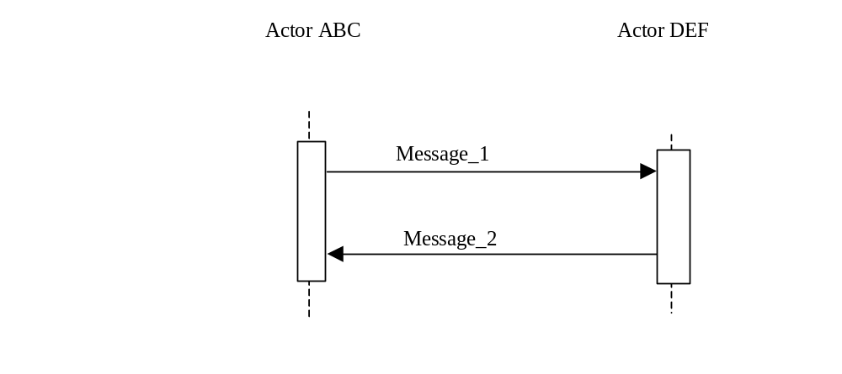
3.Y.4.1 <Message_1 Name>
<One or two sentence description of the first message of the above interaction diagram, typically relating the message to the relevant standard>

3.Y.4.1.1 Trigger Events
<description of the real world events that cause the initiation of the first message>

3.Y.4.1.2 Message Semantics
<detailed description of the meaning, structure and contents of the first message including any IHE specific clarifications of the message format, attributes, etc.>

3.Y.4.1.3 Expected Actions
<description of the actions expected to be taken as a result of sending or receiving this message>

3.Y.4.2 <Message_2 Name>
<One or two sentence description of the the next message in the above interaction diagram, typically relating the message to the relevant standard. Note, repeat this section as necessary based on the number of messages in the interaction diagram>

3.Y.4.2.1 Trigger Events
<description of the real world events that cause the initiation of the next message>

3.Y.4.2.2 Message Semantics
<detailed description of the meaning, structure and contents of the next message including any IHE specific clarifications of the message format, attributes, etc.>

3.Y.4.2.3 Expected Actions
<description of the actions expected to be taken as a result of sending or receiving this message>

3.Y.5 Security Considerations
<description of the transaction specific security consideration. Such as use of security profiles. >

3.Y.5.1 Security Audit Considerations
<This section should specifiy any specific ATNA security audit event that is associated with this transaction and requirements on the encoding of that audit event. >

3.Y.5.1.(z) Actor Specific Security Considerations
<This section should specifiy any specific security considerations on an Actor by Actor basis.>

5.0 Namespaces and Vocabularies
<This section lists the namespaces and identifiers defined or referenced by the IHE PCC Technical Framework, and the vocabularies defined or referenced therein. Additional namespaces and vocabularies shall be added to the table in the following format. For specific examples see PCC TF-2:5.0>
codeSystem | codeSystemName | Description

5.1 IHE Format Codes
<This section contains a table that lists the format codes, template identifiers and media types used by the IHE Profiles specified in the PCC Technical Framework, and also lists, for reference purposes the same values for other selected IHE Profiles from other committees. For specific examples see PCC TF-2:5.1>

Profile | Format Code | Media Type | Template ID
2010 Profiles

6.0 PCC Content Modules

6.2 Folder Content Modules

Add section 6.2.Y
6.2.Y <Folder Specification Name>
<This section corresponds to Folder Specification Y of the IHE Technical Framework. Folders are typically used to manage content profiles. This section may or may not be present depending on the issues the profile addresses.>

6.3 HL7 Version 3.0 Content Modules

6.3.1 CDA Document Content Modules

Add section 6.3.1.A
6.3.1.A <Document Content Module Specification Name>
<This section corresponds to Document Content Module Specification A of the IHE Technical Framework. This section may or may not be present depending on the issues the profile addresses.>

6.3.2 CDA Header Content Modules
Add section 6.3.2.B
6.3.2.B <Header Content Module Specification Name>
<This section corresponds to Header Content Module Specification B of the IHE Technical Framework. This section may or may not be present depending on the issues the profile addresses.>

6.3.3 CDA Section Content Modules
Add section 6.3.3.C
6.3.3.C <Section Content Module Specification Name>
<This section corresponds to Section Content Module Specification C of the IHE Technical Framework. This section may or may not be present depending on the issues the profile addresses.>

6.3.4 CDA Entry Content Modules
Add section 6.3.4.D
6.3.4.D <Entry Content Module Specification Name>
<This section corresponds to Entry Content Module Specification D of the IHE Technical Framework. This section may or may not be present depending on the issues the profile addresses.>

6.5 PCC Value Sets
Add section 6.5.A
6.5.A <Value Set Name>
<This section corresponds to Value Set A of the IHE Technical Framework. This section may or may not be present depending on the issues the profile addresses.>

<Appendix letter> Appendix_Name
<Detailed cross transaction relationships or mapping details are described in an appendix in Volume 2>

